**Longitudinal Story Time: Practice Thinking about Time-Invariant Predictors**

1. Project for Kelly Farquharsen (UNL; now at Florida State University): Early Babbling and Later Reading

* 12 children; 8 occasions at 3-month intervals from **ages 9–30 months**
* Outcome is constant–vowel (CV) ratio; letter identification also measured **at 72 months only**
* Research Question: Does growth in speech complexity from 9–30 months predict later pre-reading skills at 72 months?

1. MA for Kathleen Kelsey Earnest (UNL, now at KU): Growth in Motor Inhibition and Delayed Gratification in Preschoolers

* 379 children; 4 occasions at 9-month intervals from ages 3.0–5.25 years (end= time 0; plot below is saturated vs. linear-predicted means)
* 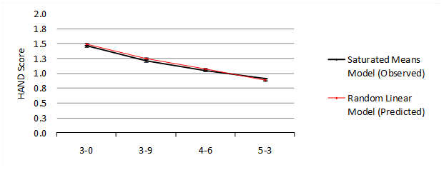26% of mothers smoked at least once during pregnancy
* Two outcomes from snack delay task: motor movement and eat snack: yes/no?
* Research Questions for each outcome:
  + What is the effect of prenatal tobacco exposure on growth over time?
  + Do these smoking effects on growth vary by child gender?
  + To what extent do these smoking effects remain after controlling for SES?

1. Office Hours Continued Discussion: Treatment Effects in Persons with Severe Mental Illness

* ~24 persons initially, down to 12 by end of study; 3 occasions; multiple outcomes of mental health
* Treatment group occasions = before, after, follow-up; Wait-list control = before, before, after
* Research Question: Does treatment work?

Wave 1 Wave 2 Wave 3

**Treated** **Wait-List Control**

4. Workshop Participant Question: Effects of Remediation on Property Values

* Annual property values for two kinds of homes across 18 years: remediated or not
* Public meeting about need for remediation occurred in year 6; clean-up started in year 14
* 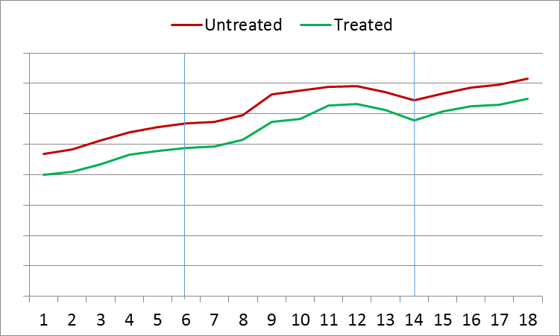Research Question: Did remediation harm property values? (see plot below of observed means)