Longitudinal MLM Bonus Story Time: Practice Thinking about Time-Invariant Predictors
A researcher comes to you for data analysis advice. They have a sample of 379 children measured at 4 occasions (9-month intervals) from ages 3.0-5.25 years. Of interest are sex differences, as well as differences between children whose mothers smoked during pregnancy (26% of sample) or not. The outcome is amount of child motor movement during a "delay of gratification" task (in which the experimenter leaves the room, and the children are told to sit still and to not eat the snack placed in front of them until the experimenter returns). Using an equation and/or words, describe a longitudinal model that would answer the following questions:
- What is the effect of prenatal tobacco exposure on improvement over time in child motor movement?
- Does the effect of prenatal tobacco exposure on growth over time vary between girls and boys?

$$motor_{ti}=β_{0i}+β_{1i}\left(time_{ti}\right)$$
$$β_{0i}=γ_{00}+γ_{01}\left(Exp_{i}\right)+γ_{02}\left(SES_{i}\right)+γ_{03}(boy_{i})+γ_{04}(Exp_{i})(boy_{i})+U_{0i} \\ β_{1i}=γ_{10}+γ_{11}(Exp_{i})+γ_{12}(SES_{i})+γ_{13}(boy_{i})+γ_{14}(Exp_{i})(boy_{i})+U_{1i}$$
lmer(data=whatever, REML=TRUE,
formula=motor~1+time+Exp+SES +time:Exp +time:SES +boy +time:boy + Exp:boy + time:Exp:boy +(1+time|ID)
A different researcher comes to you for data analysis advice. They conducted a randomized control trial in which children were assigned to either a control group or a treatment group. The children were measured repeatedly (5-7 observations) during each of three conditions: a baseline phase (in which both groups had the same procedures), during intervention (in which the treatment group had something different), and after intervention (in which both groups again had the same procedures). There are differences between children in how many observations were collected during each phase, and not all children were available to complete the after-intervention phase. The research team originally averaged over the observations within each phase to conduct a mixed-design analysis of variance (with a within-subjects factor of condition and a between-subjects factor of treatment group), but reviewer 2 was concerned about their handling of missing data in doing so. How could multilevel models be used to: (1) better address missing data, and (2) avoid losing information by aggregating within each phase?
$$behavior_{ti}= β_{0i}+β_{1i}\left(Phase{1vs2}_{ti}\right)+β_{2i}\left(Phase{2vs3}_{ti}\right)$$ $+β_{3i}\left(timeInPhase\right)+β_{4i}\left(timeInPhase\right)\left(Phase{1vs2}_{ti}\right)$ $$+β_{5i}\left(timeInPhase\right)\left(Phase{2vs3}_{ti}\right)$$
The model for the variance was not added because I instead showed the multivariate MLM I actually used (in which within-phase slopes were not significant and were thus not included—this slide is from the June 2022 CASMA workshop I gave at U Iowa):
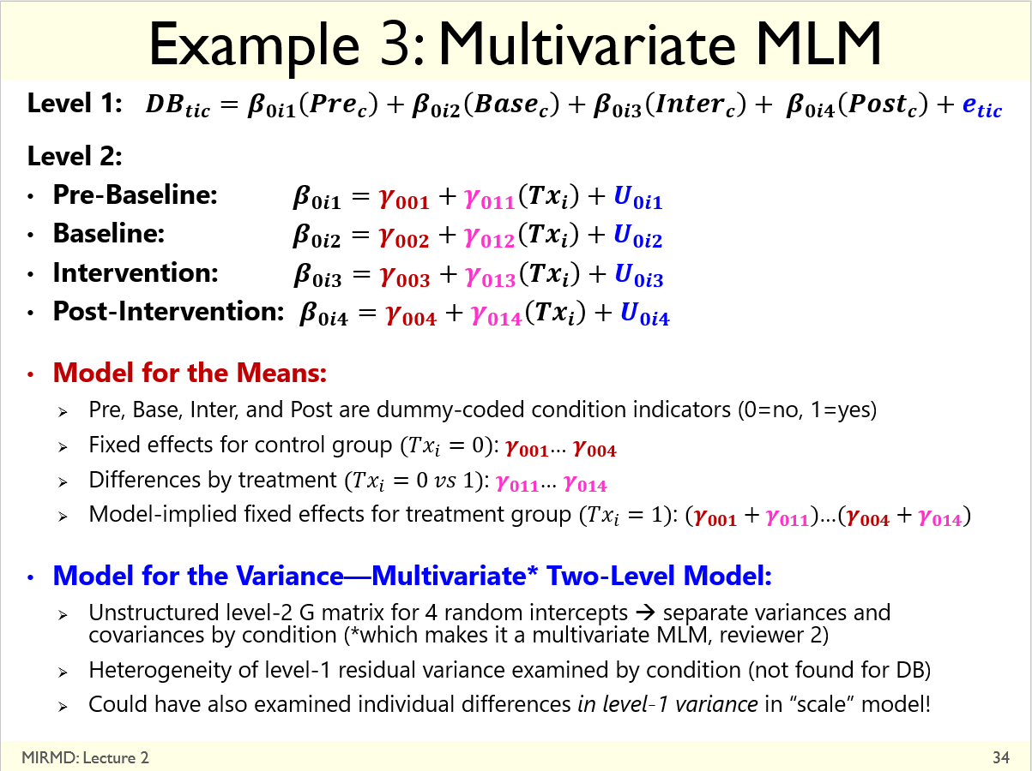

Office Hours Continued Discussion: Treatment Effects in Persons with Severe Mental Illness
- ~24 persons initially, down to 12 by end of study; 3 occasions; multiple outcomes of mental health
- Treatment group occasions = before, after, follow-up; Wait-list control = before, before, after
- Research Question: Does treatment work?
Wave 1 Wave 2 Wave 3
Treated Wait-List Control

- Primary model for the means using first occasion as time 0
and wait-list control as reference
$$Level 1: {Health}_{ti}=β_{0i}+β_{1i}\left(Slope1_{ti}\right)+β_{2i}\left(Slope2_{ti}\right) \\ Level 2 Intercept: β_{0i}=γ_{00}+γ_{01}\left({Treat}_{i}\right) \\ Level 2 Slope1: β_{1i}=γ_{10}+γ_{11}\left({Treat}_{i}\right)$$
$$Level 2 Slope2: β_{2i}=γ_{20}+γ_{21}\left({Treat}_{i}\right)$$

Workshop Participant Question: Effects of Remediation on Property Values
- Annual property values for two kinds of homes across 18 years: remediated or not
- Public meeting about need for remediation occurred in year 6; clean-up started in year 14
- Research Question: Did remediation harm property values? (see plot below of observed means)

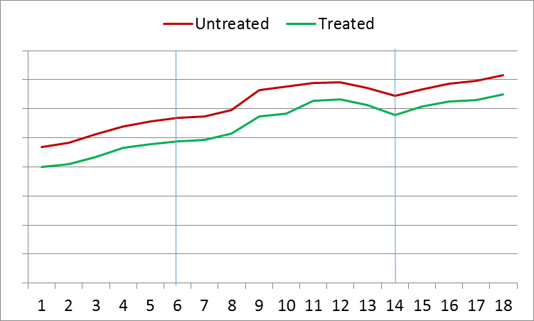
- Example model for the means using first occasion as time 0 and untreated as reference
$$Level 1: Value_{ti}=β_{0i}+β_{1i}\left(Slope1_{ti}\right)+β_{2i}\left(Jump2_{ti}\right)+β_{3i}\left(Slope2_{ti}\right)+β_{4i}\left(Jump3_{ti}\right)+β_{5i}\left(Slope3_{ti} \right) \\ Level 2 Intercept: β_{0i}=γ_{00}+γ_{01}\left({Treat}_{i}\right) \\ Level 2 Slope1: β_{1i}=γ_{10}+γ_{11}\left({Treat}_{i}\right)$$
$$Level 2 Jump2: β_{2i}=γ_{20}+γ_{21}\left({Treat}_{i}\right) \\ Level 2 Slope2: β_{3i}=γ_{30}+γ_{31}\left({Treat}_{i}\right)$$
$$Level 2 Jump3: β_{4i}=γ_{40}+γ_{41}\left({Treat}_{i}\right) \\ Level 2 Slope3: β_{5i}=γ_{50}+γ_{51}\left({Treat}_{i}\right)$$

