Longitudinal Story Time: Practice Thinking about Time-Invariant Predictors
- Kelly Farquharsen (UNL; now at Emory College): Early Babbling and Later Reading
- 12 children; 8 occasions at 3-month intervals from ages 9–30 months
- Outcome is constant–vowel (CV) ratio; letter identification also measured at 72 months only
- Research Question: Does growth in speech complexity predict later pre-reading skills?
- Primary Model for CV ratio
$$Level 1: {CVratio}_{ti}=β_{0i}+β_{1i}\left(Age_{ti}-12\right)+β_{2i}{\left(Age_{ti}-12\right)}^{2}+e_{ti} \\ Level 2 Intercept: β_{0i}=γ_{00}+γ_{01}\left({LetterID}_{i}-35\right)+U_{0i} \\ Level 2 Linear Age: β_{1i}=γ_{10}+γ_{11}\left({LetterID}_{i}-35\right) \\ Level 2 Quadratic Age: β_{2i}=γ_{20}+γ_{21}\left({LetterID}_{i}-35\right)$$

TITLE "Saturated Means, Random Intercept";
PROC MIXED DATA=work.stacked NOCLPRINT NOITPRINT COVTEST METHOD=REML;
CLASS SubjectID age;
MODEL CVRatio = age / SOLUTION DDFM=KR;
RANDOM INTERCEPT / TYPE=UN SUBJECT=SubjectID;
LSMEANS age;
RUN;

TITLE "Effects of Letter ID on intercept, linear, and quadratic";
PROC MIXED DATA=work.stacked NOCLPRINT NOITPRINT COVTEST METHOD=REML;
CLASS SubjectID;
MODEL CVRatio = age12 age12*age12 let35 let35*age12 let35*age12*age12 / SOLUTION DDFM=KR;
RANDOM INTERCEPT / TYPE=UN SUBJECT=SubjectID;
* Simple effects of letter ID by age;
ESTIMATE "Let Effect AT MONTH 9" let35 1 let35*age12 -3 let35*age12*age12 9;
ESTIMATE "Let Effect AT MONTH 12" let35 1 let35*age12 0 let35*age12*age12 0;
ESTIMATE "Let Effect AT MONTH 15" let35 1 let35*age12 3 let35*age12*age12 9;
ESTIMATE "Let Effect AT MONTH 18" let35 1 let35*age12 6 let35*age12*age12 36;
ESTIMATE "Let Effect AT MONTH 21" let35 1 let35*age12 9 let35*age12*age12 81;
ESTIMATE "Let Effect AT MONTH 24" let35 1 let35*age12 12 let35*age12*age12 144;
ESTIMATE "Let Effect AT MONTH 27" let35 1 let35*age12 15 let35*age12*age12 225;
ESTIMATE "Let Effect AT MONTH 30" let35 1 let35*age12 18 let35*age12*age12 324;

* Values to plot for -1, +1 SD;
ESTIMATE "INTERCEPT AT MONTH 9 for Let=32" intercept 1 age12 -3 age12*age12 9 let35 -3 let35*age12 9 let35*age12*age12 -27;
ESTIMATE "INTERCEPT AT MONTH 12 for Let=32" intercept 1 age12 0 age12*age12 0 let35 -3 let35*age12 0 let35*age12*age12 0;
ESTIMATE "INTERCEPT AT MONTH 15 for Let=32" intercept 1 age12 3 age12*age12 9 let35 -3 let35*age12 -9 let35*age12*age12 -27;
ESTIMATE "INTERCEPT AT MONTH 18 for Let=32" intercept 1 age12 6 age12*age12 36 let35 -3 let35*age12 -18 let35*age12*age12 -108;
ESTIMATE "INTERCEPT AT MONTH 21 for Let=32" intercept 1 age12 9 age12*age12 81 let35 -3 let35*age12 -27 let35*age12*age12 -243;
ESTIMATE "INTERCEPT AT MONTH 24 for Let=32" intercept 1 age12 12 age12*age12 144 let35 -3 let35*age12 -36 let35*age12*age12 -432;
ESTIMATE "INTERCEPT AT MONTH 27 for Let=32" intercept 1 age12 15 age12*age12 225 let35 -3 let35*age12 -45 let35*age12*age12 -675;
ESTIMATE "INTERCEPT AT MONTH 30 for Let=32" intercept 1 age12 18 age12*age12 324 let35 -3 let35*age12 -54 let35*age12*age12 -972;

ESTIMATE "INTERCEPT AT MONTH 9 for Let=38" intercept 1 age12 -3 age12*age12 9 let35 3 let35*age12 -9 let35*age12*age12 27;
ESTIMATE "INTERCEPT AT MONTH 12 for Let=38" intercept 1 age12 0 age12*age12 0 let35 3 let35*age12 0 let35*age12*age12 0;
ESTIMATE "INTERCEPT AT MONTH 15 for Let=38" intercept 1 age12 3 age12*age12 9 let35 3 let35*age12 9 let35*age12*age12 27;
ESTIMATE "INTERCEPT AT MONTH 18 for Let=38" intercept 1 age12 6 age12*age12 36 let35 3 let35*age12 18 let35*age12*age12 108;
ESTIMATE "INTERCEPT AT MONTH 21 for Let=38" intercept 1 age12 9 age12*age12 81 let35 3 let35*age12 27 let35*age12*age12 243;
ESTIMATE "INTERCEPT AT MONTH 24 for Let=38" intercept 1 age12 12 age12*age12 144 let35 3 let35*age12 36 let35*age12*age12 432;
ESTIMATE "INTERCEPT AT MONTH 27 for Let=38" intercept 1 age12 15 age12*age12 225 let35 3 let35*age12 45 let35*age12*age12 675;
ESTIMATE "INTERCEPT AT MONTH 30 for Let=38" intercept 1 age12 18 age12*age12 324 let35 3 let35*age12 54 let35*age12*age12 972;
RUN;
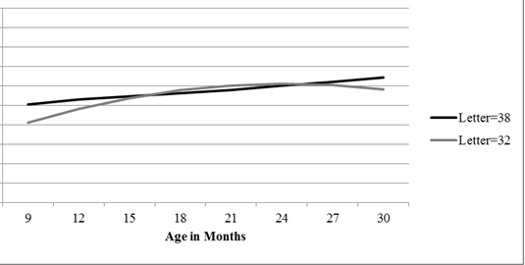

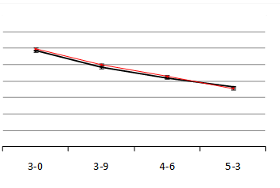
- Kathleen Kelsey Earnest (UNL, now at KU): Growth in Motor Inhibition and Delayed Gratification in Preschoolers
- 379 children; 4 occasions at 9-month intervals from ages 3.0–5.25 years
- 26% of mothers smoked at least once during pregnancy
- Two outcomes from snack delay task: motor movement and eat snack: yes/no?
- Research Questions:
  - What is the effect of prenatal tobacco exposure on each outcome?
  - Do these smoking effects vary by child gender?
  - To what extent do these effects remain after controlling for SES?
- Primary Model for Motor
$$Level 1: {Motor}_{ti}=β_{0i}+β_{1i}\left(Age_{ti}-4\right)+e_{ti} \\ Level 2 Intercept: β_{0i}=γ_{00}+γ_{01}\left({Exposed}_{i}\right)+γ_{02}\left({Girl}_{i}\right)+γ_{03}\left({Exposed}_{i}\right)\left({Girl}_{i}\right)+U_{0i} \\ Level 2 Linear Age: β_{1i}=γ_{10}+γ_{11}\left({Exposed}_{i}\right)+γ_{12}\left({Girl}_{i}\right)+γ_{13}\left({Exposed}_{i}\right)\left({Girl}_{i}\right)+U_{1i}$$
TITLE "Effects of Exposure and Gender on Intercept and Linear Change ";
PROC MIXED DATA=work.stacked NOCLPRINT NOITPRINT COVTEST METHOD=REML;
CLASS SubjectID age;
MODEL motor = age4|exp|girl@3 / SOLUTION DDFM=KR;
RANDOM INTERCEPT age4 / GCORR TYPE=UN SUBJECT=SubjectID;
* Simple effects of exposure for boys;
ESTIMATE "Exposure Effect at 36 months (wave 1) for Boys" exp 1 exp*age4 -3 exp*girl 0 exp*girl*age4 0;
ESTIMATE "Exposure Effect at 45 months (wave 2) for Boys" exp 1 exp*age4 -2 exp*girl 0 exp*girl*age4 0;
ESTIMATE "Exposure Effect at 54 months (wave 3) for Boys" exp 1 exp*age4 -1 exp*girl 0 exp*girl*age4 0;
ESTIMATE "Exposure Effect at 63 months (wave 4) for Boys" exp 1 exp*age4 0 exp*girl 0 exp*girl*age4 0;
ESTIMATE "Exposure Effect on Linear Slope for Boys" exp*age4 1 exp*girl*age4 0;
RUN;
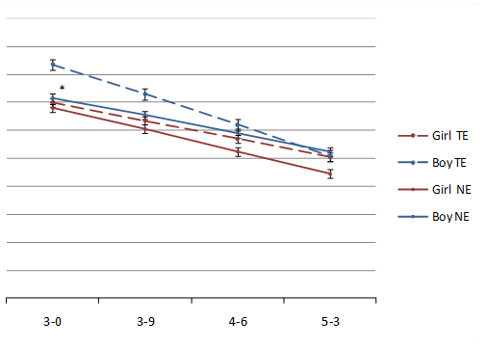

- Treatment Effects in Persons with Severe Mental Illness
- ~24 persons initially, down to 12 by end of study; 3 occasions; multiple outcomes of mental health
- Treatment group occasions = before, after, follow-up; Wait-list control = before, before, after
- Research Question: Does treatment work?
- Primary model for the means using first occasion as time 0 and wait-list control as reference
$Level 1: {Health}_{ti}=β_{0i}+β_{1i}\left(Slope1_{ti}\right)+β_{2i}\left(Slope2_{ti}\right)$$$Level 2 Intercept: β_{0i}=γ_{00}+γ_{01}\left({Treat}_{i}\right) \\ Level 2 Slope1: β_{1i}=γ_{10}+γ_{11}\left({Treat}_{i}\right)$$
Wave 1 Wave 2 Wave 3
Treated Wait-List Control
$$Level 2 Slope2: β_{2i}=γ_{20}+γ_{21}\left({Treat}_{i}\right)$$
* Creating piecewise slopes;
DATA work.stacked; SET work.stacked;
IF wave=1 THEN DO; slope1=0; slope2=0; END;
IF wave=2 THEN DO; slope1=1; slope2=0; END;
IF wave=3 THEN DO; slope1=1; slope2=1; END;
RUN;
TITLE "Effects of Treatment on Change";
PROC MIXED DATA=work.stacked NOCLPRINT NOITPRINT COVTEST METHOD=REML;
CLASS Subject wave;
MODEL health = slope1|treat@2 slope2|treat@2 / SOLUTION DDFM=KR;
REPEATED wave / RCORR TYPE=UN SUBJECT=Subject;
* Simple effects of group;
ESTIMATE "Treat Effect at Wave 1" treat 1 treat*slope1 0 treat*slope2 0;
ESTIMATE "Treat Effect at Wave 2" treat 1 treat*slope1 1 treat*slope2 0;
ESTIMATE "Treat Effect at Wave 3" treat 1 treat*slope1 1 treat*slope2 1;
ESTIMATE "Slope1 for Wait Group" slope1 1 treat*slope1 0;
ESTIMATE "Slope2 for Wait Group" slope2 1 treat*slope2 0;
ESTIMATE "Slope1 for Treat Group" slope1 1 treat*slope1 1;
ESTIMATE "Slope2 for Treat Group" slope2 1 treat*slope2 1;
ESTIMATE "Group Diff in Treatment?" slope2 -1 slope1 1 slope1*treat 1;
RUN;
Is this model likely to be sufficient?

4. Effects of Remediation on Property Values
- Annual property values for two kinds of homes across 18 years: remediated or not
- Public meeting about need for remediation occurred in year 6; clean-up started in year 14
- Research Question: Did remediation harm property values?
- Example model for the means using first occasion as time 0 and untreated as reference
$$Level 1: Value_{ti}=β_{0i}+β_{1i}\left(Slope1_{ti}\right)+β_{2i}\left(Jump2_{ti}\right)+β_{3i}\left(Slope2_{ti}\right)+β_{4i}\left(Jump3_{ti}\right)+β_{5i}\left(Slope3_{ti} \right) \\ Level 2 Intercept: β_{0i}=γ_{00}+γ_{01}\left({Treat}_{i}\right) \\ Level 2 Slope1: β_{1i}=γ_{10}+γ_{11}\left({Treat}_{i}\right)$$
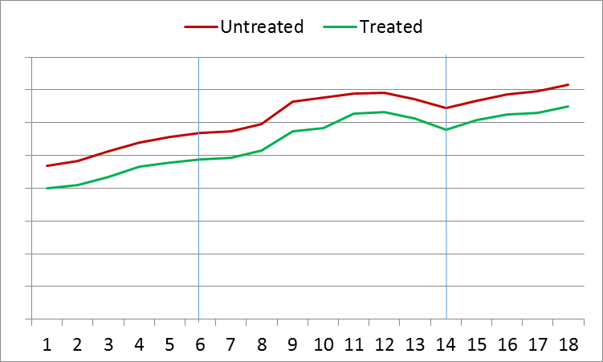
$Level 2 Jump2: β_{2i}=γ_{20}+γ_{21}\left({Treat}_{i}\right)$
$$Level 2 Slope2: β_{3i}=γ_{30}+γ_{31}\left({Treat}_{i}\right)$$
$$Level 2 Jump3: β_{4i}=γ_{40}+γ_{41}\left({Treat}_{i}\right) \\ Level 2 Slope3: β_{5i}=γ_{50}+γ_{51}\left({Treat}_{i}\right)$$

* Creating piecewise slopes;
DATA work.stacked; SET work.stacked;
* Continuous slope1 throughout entire study;
slope1=year-1;
* Change in intercept and slope after meeting in year 6;
IF year LE 6 THEN DO; jump2=0; slope2=0; END;
ELSE IF year GT 6 THEN DO; jump2=1; slope2=year-6; END;
* Change in intercept and slope after cleanup in year 14;
IF year LE 14 THEN DO; jump3=0; slope3=0; END;
ELSE IF year GT 14 THEN DO; jump3=1; slope3=year-14; END;
* Phases;
IF year GT 0 AND year LE 6 THEN phase=1;
ELSE IF year GT 6 AND year LE 14 THEN phase=2;
ELSE IF year GT 14 AND year LE 18 THEN phase=3;
RUN;

TITLE "Effects of Remediation on Property Values";
PROC MIXED DATA=work.stacked NOCLPRINT NOITPRINT COVTEST METHOD=REML;
CLASS HouseID year;
MODEL value = slope1|treat@2 jump2|treat@2 slope2|treat@2 jump3|treat@2 slope3|treat@2 / SOLUTION DDFM=KR;
RANDOM INTERCEPT / TYPE=UN SUBJECT=HouseID;
REPEATED year / TYPE=VC SUBJECT=HouseID;
RUN;

Is this model likely to be sufficient?

